**Karan Arora**  **R.L. Institute M: 9416974837**

**Max Time : 1 hr** **Class = 12th Chemistry Test**  **Max Marks : 25**

**SOLUTION – 1**

1. Multiple choice questions : [ 1 X 16 = 16]
2. Molar solubility of He , N2 and O2 are plotted against partial pressure of the gas at constant temperature.

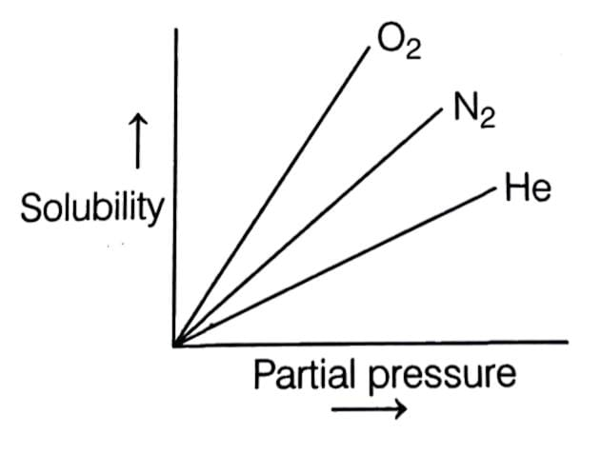

Henry’s law constant for these gases will lie in the sequence as :

|  |  |  |  |
| --- | --- | --- | --- |
| a) O2 > N2 > He | b) O2 < N2 < He | c) O2 = N2 = He | d) O2 > N2 < He |

1. Which of the following statements is incorrect?
2. The solution which show a large positive deviation from Raoult’s law will form minimum boiling azeotropes at specific compositions.
3. Azeotropes mixture are binary mixture having same composition in liquid and vapour phase.
4. The solutions which show a large negative deviation from Raoult’s law form a maximum boiling azeotropes.
5. Chloroform and diethyl ether show positive deviation from Raoult’s law.

choose the correct option:

|  |  |  |  |
| --- | --- | --- | --- |
| a) Only (i) | b) Only (ii) | c) (ii) & (iv) | d) Only (iv) |

1. If 120 mL of liquid A and 25 mL of liquid B are mixed to form a solution of volume 145 mL, then the solution is :

|  |  |
| --- | --- |
| a) ideal solution | b) non-ideal with positive deviation |
| c) non-ideal with negative deviation | d) cannot be predicted |

1. 5 Molar, 1 L solution of an acid is divided in two equal halves, molarity of each half is :

|  |  |  |  |
| --- | --- | --- | --- |
| a) 1.25 M | b) 2.5 M | c) 5 M | d) unpredictable |

1. The concentration in ppm of a solution which contains 10 g of Na2CO3 in 106 g solution nearly is :

|  |  |  |  |
| --- | --- | --- | --- |
| a) 8 | b) 10 | c) 6 | d) 12 |

1. 64 g of oxygen is present in 5 L vessel. The molar concentration of oxygen is :

|  |  |  |  |
| --- | --- | --- | --- |
| a) 0.2 | b) 1.6 | c) 0.4 | d) 0.8 |

1. A 5 molar solution of H2SO4 is diluted from 1 L to a volume of 10 L, the normality of the solution will be :

|  |  |  |  |
| --- | --- | --- | --- |
| a) 1 N | b) 0.1 N | c) 5 N | d) 0.5 N |

1. Which of the following liquid will have highest vapour pressure at room temperature?

|  |  |  |  |
| --- | --- | --- | --- |
| a) ethyl alcohol | b) Acetone | c) Water | d) propyl alcohol |

1. A solution is made by dissolving a non-volatile solute ‘X’ in a solvent ‘Y’ at 300 K. The vapour pressure over the mercury reduces from 50 mm to 45 mm. The mole fraction of ’Y’ in the solution will be :

|  |  |  |  |
| --- | --- | --- | --- |
| a) 0.06 | b) 0.08 | c) 0.9 | d) 0.5 |

1. Colligative property amongst the following is :

|  |  |  |  |
| --- | --- | --- | --- |
| a) surface tension | b) viscosity | c) osmotic pressure | d) optical rotation |

1. Brass is a solution of :

|  |  |  |  |
| --- | --- | --- | --- |
| a) solid in solid | b) solid in liquid | c) gas in solid | d) liquid in solid |

1. Which of the following is incorrect for ideal solution?
2. ${∆H}_{mixing}$ = 0
3. ${∆V}_{mixing}$ = 0
4. Does not obey Raoult’s law over entire range of concentration.
5. A – A , B – B interactions are equal to A – B interactions.
6. The molarity of a solution obtained by mixing 750 mL of 0.5 M HCl with 250 mL of 2 M HCl will be :

|  |  |  |  |
| --- | --- | --- | --- |
| a) 0.975 M | b) 0.875 M | c) 1 M | d) 1.175 M |

1. 23 g ethanol is dissolved in 36 g of water? Find mole fraction of ethanol?

|  |  |  |  |
| --- | --- | --- | --- |
| a) 2 | b) 0.5 | c) 0.2 | d) 0.8 |

1. What is the Molarity of 1 N H2SO4 solution?

|  |  |  |  |
| --- | --- | --- | --- |
| a) 1 M | b) 2 M | c) 0.5 M | d) 3 M |

1. Value of Henry’s constant KH ___________.

|  |  |
| --- | --- |
| a) increases with increase in temperature | b) decreases with increase in temperature |
| c) remains constant | d) First increases, then decreases |

1. Define Molarity and Molality. [ 2 ]
2. How many grams of Na2CO3 should be dissolved in 250 g of water to prepare 0.1 m solution?

[ 2 ]

1. Define Henry’s law. [ 2 ]
2. Write 3 points difference between Ideal and Non-Ideal solution. [ 3 ]